The QuicKart Start Guide

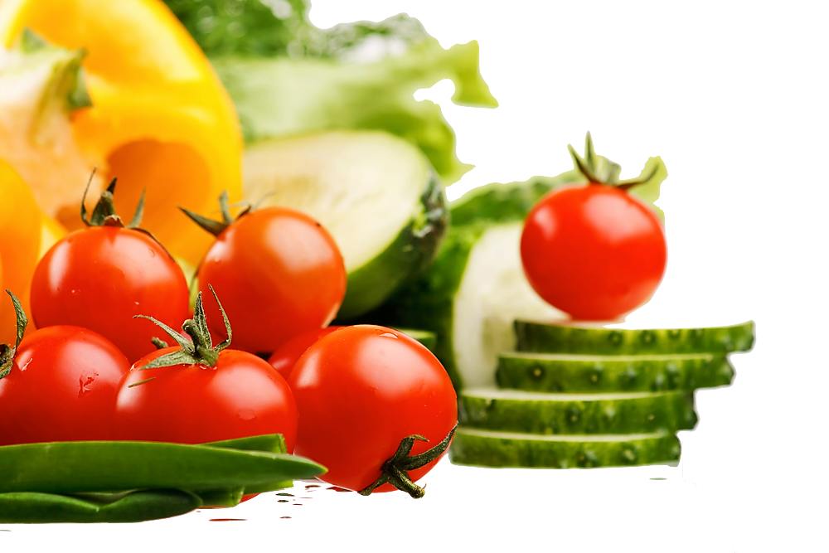

[This Photo](https://freepngimg.com/png/13863-healthy-food-free-download-png) by Unknown Author is licensed under [CC BY-NC](https://creativecommons.org/licenses/by-nc/3.0/)

Table of Contents

Proper Use 4

Safety 4

The QuicKart Start Guide 5

Icon Key 5

Getting Started 6

Device requirements 6

Installation 6

Creating an Account 6

Creating Your Shopping List 7

Searching for Items 7

Adding items 7

Removing items 8

Viewing your total 8

Beginning Your Route 9

Viewing the next item 9

Adding items 9

Removing items 9

Ending the shopping trip 9

Accessibility 11

Accessing accessibility controls 11

Color blindness 11

Screen readers 11

Troubleshooting 12

Infinite loading screen 12

Total does not update 12

Route calculation error 12

Delay when adding items to list 12

Contact Us 13

Glossary 14

Index 15

Version History 16

# Usage

# Safety

Using QuicKart can cause users to pay less attention to their surroundings. When using the QuicKart app, be aware of your surroundings

in grocery stores.

QuicKart is not responsible for any damage caused or injury ensued if the user did not pay attention to their environment.

# The QuicKart Start Guide

From increasing prices to store layouts that seem like a maze, grocery shopping can be a hassle. The QuicKart app is a mobile application designed to optimize shopping trips by calculating and mapping the most efficient route based on the items in your personalized shopping list.

QuicKart aims to eliminate the need for long shopping trips to allow you more time to do more activities you love and spend less time and money in grocery stores.

Our goal is to better your grocery store shopping experience with one click of a button!

Let us get started!

## Icon Key

|  |  |
| --- | --- |
| Lights On with solid fill | Helpful information |
| Irritant with solid fill | Warning |
|  |  |

# Getting Started

## Device requirements

|  |  |
| --- | --- |
| Operating System | Android or iOS |
| Internet Connection | Required |

## Installation

The QuicKart app is compatible on any Android or iOS mobile device.

To install the app, visit your device’s app store and search for “QuicKart.” Alternatively, visit our website at <https://quickart.github.io> to download our app on your device, and follow the installation prompts to get started.

## Creating an Account

TBA

# Creating Your Shopping List

## Searching for Items

With the searchable dropdown feature, searching for items never got easier.[1]

To search for an item in your store location:

1. Click on the search bar at the top of the screen
2. Begin entering the desired item name or scroll through the list to find your desired item

(ex) banana, eggs, French fries, waffles

## Adding items

Once you finished searching for your desired item, you will have the ability to add items to your shopping list before you calculate your shopping route.

To add items to your shopping list:

1. Search for an item in the dropdown list
2. Click on your desired item

If you do not add all desired items to your shopping list at this point, you will have the opportunity to add more items after starting your shopping route by clicking the **Start Shopping** button.

See Searching for Items to determine how to search for a grocery item in the store inventory.

## Removing items

To remove an item from your shopping list, click on the trash can icon next to item. This will permanently modify your shopping list.

Be mindful that you cannot undo this change. To restore that item to your shopping list, you must search for the item again in the dropdown list.

See Searching for Items to determine how to search for a grocery item in the store inventory.

## Viewing your total

On the **Create Your Shopping List** screen, you can view your total at the bottom of the screen. This total will reflect all changes (e.g., additions and removals) to your shopping list.

Keep in mind that your total in the QuicKart app does not reflect any sales taxes for your locale. Ensure that your budget accurately reflects any taxes and additional fees.

This is a good way for you to be mindful of how much you spend at the grocery store to stay within budget before and during your shopping trip!

# Beginning Your Route

## Viewing the next item

Each item in your shopping route will be displayed at the top of the Shopping Route screen. The data will always reflect the current item in your shopping route.

To view the next item in your shopping route, click the Next button. If you have remaining uncollected items, this will update the display to show the next item in your route.

You will not be able to utilize the Next button if you completed your route.

Clicking the Next button will also update the checklist at the bottom of the screen to indicate that you collected that item.

Once you click Next, you cannot go back to the previous item. If you would like to restore that item, you must add that item back to the list.

See Adding Items to learn how to add an item to the list on the Shopping Route screen.

## Modifying your list

Once you begin your shopping route, you may want to modify your shopping list by adding or removing items.

Adding items

To add additional items to your shopping list, click the **Add** button. Then, search for the item you would like add to your shopping list.

Removing items

To remove items from your list, click the trash can icon next to the desired item.

## Ending the shopping trip

Once you retrieved all your items in the shopping list, click the **Finish Shopping** button to terminate your shopping trip and see the total calculated time spent shopping.

# Accessibility

## Accessing accessibility controls

## Color blindness

## Screen readers

# Troubleshooting

## Shopping route screen does not load

Ensure that you added at least one item to your shopping list on the Create Your Shopping List screen. A route cannot generate if the shopping list is empty.

1. Click on the back button to go back to the Create Your Shopping List screen
2. Verify that there is one item in the shopping list. If not, proceed to the next step.
3. Restart the app.

If none of these solutions fix the problem, please contact the QuicKart team.

## Infinite loading screen

An infinite loading screen is indicative of an inability to connect to our servers. Please check your network connection to verify that you have a stable connection. If your network connection is intermittent, then you may experience issues with connecting to the QuicKart servers.

See Device Requirements to determine the minimum internet connection speed when using the QuicKart app.

If you continue to experience this issue, please contact the QuicKart team to further information.

# Contact Us

# Index

A

Account 2, 6

D

download 6

I

install 6

Q

QuicKart 1, 2, 4, 5, 6, 8, 12

S

search 6, 7, 8, 10

search bar 7

searchable dropdown 7

# Version History

|  |  |
| --- | --- |
| *Version* | *Project Members* |
| V1 - *Enterprise* | Abdullahi Munye – ***Data Modeler***  Alan Oliver Santiesteban – ***Team Manager***  Joe Nsengiyumva – ***Testing Lead***  Khamilah Nixon – ***Documentation Lead***  Kyle Williams – ***Code Architect***  Raven Gardner – ***UI/UX Designer*** |

1. Individual stores with their own unique inventories are not present in this version of the app. Currently, you can only search from a select number of predetermined generic grocery items.